CENWP-OD-D 22 October 2015 updated on 4 November 2015

MEMORANDUM FOR THE RECORD

SUBJECT: 15TDA11 MFR – Fish Stranding in Fishlock

On Oct 21 during a routine inspection fish were noticed on the water surface of the fish lock. At least 8 salmonids were observed when sunlight conditions were right, allowing part of the surface area to be visible. Attempts will be made to devise a trap for removal.The system is not used and it appears all bulkheads and trashracks are in place. Point of entry remains unknown. Investigations will continue. The area will be added to the dewatering plans, if necessary, to help determine possible openings.

- Species –Steelhead and possible sockeye
- Origin - unknown
- Length –NA
- Marks and tags - NA
- Marks and Injuries found on carcass – NA
- Cause and Time of Death – not dead yet
- Future and Preventative Measures – Locate point of entry and correct it

UPDATE 27 October 2015:
On further investigation it is believed the fish entered from the cul-de-sac into the fishlock discharge pipe. There is a closed butterfly valve in this section of pipe. However, the rubber seals are suspected to be degraded due to age and this has been an issue with other butterfly valves in this location. This leaves a several inch gap along the side of the valve, allowing access into the fishlock. A head pressure is normal for this system due to the need for irrigation at Patterson park. The entire system was thought to be contained and isolated from tailwater.
Attempts were made to devise a trap for removal, but were unsuccessful after several days. The next step is to install forebay bulkheads to stop the leakage flow and prevent any further attraction to this area. We will assess feasibility to safely access this area for fish removal. Since this has never been done, many challenges are expected. We will need to determine a new operational plan for next season to prevent this from occurring again. This valve room is planned to be demolished and the intake pipe will be capped during the AWS backup contract work, scheduled for the winter of 2016 and 2017, which will correct the problem.

UPDATE 4 November 2015:
The forebay bulkheads were installed on 26 October to stop leakage flow and prevent any further attraction to this area. The area within the fishlock itself has no means of dewatering. An ROV was dropped in the cylindrical part of fish lock to assess structure and fish numbers. No fish were observed. Two levels of bubbler beams were encountered preventing further ROV depth beyond 12 feet. It has been determined that feasibility and safe access into the area cannot be achieved; therefore dewatering salvage is not an option. Modifications will be made to the fish trap. If fish are observed, hook & line method may be used.

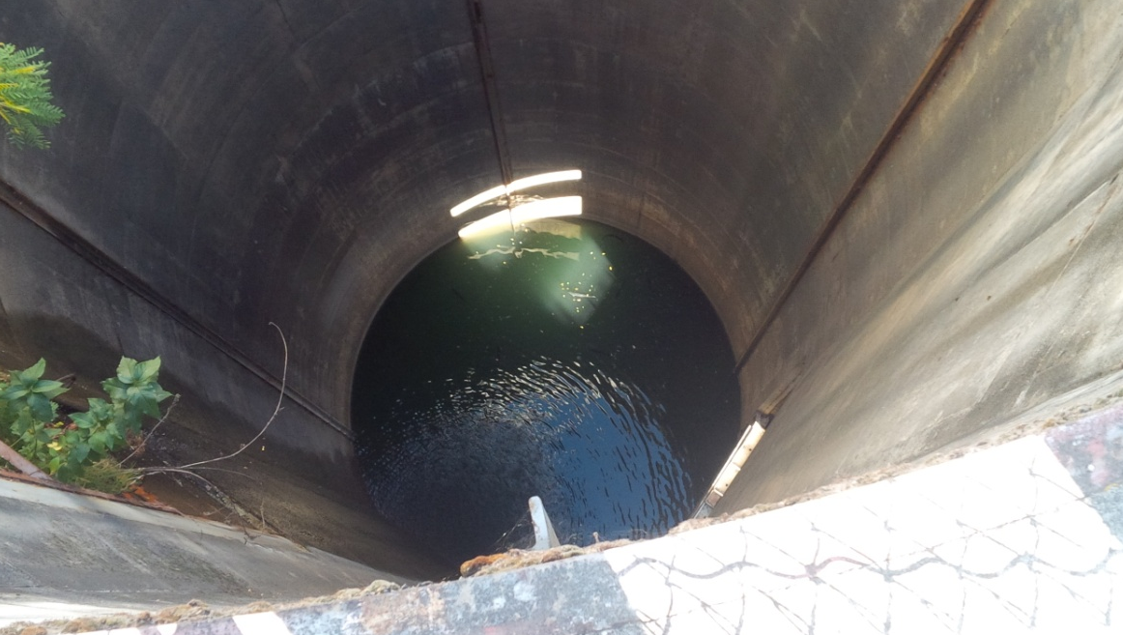

Schematic of piping and valves associated with fish lock. Large pipe exiting system (lower right) leads to outlet in cul-de-sac, where fish entry is suspected. Intake penstock (upper left) is location of bulkheads which were installed to stop flow. Cylindrical portion above baffle beams is location of fish observed.

Thank you,
The Dalles Project Fisheries

Comments from agencies
NOAA-----Original Message-----
From: Gary Fredricks - NOAA Federal [mailto:gary.fredricks@noaa.gov]
Sent: Friday, October 23, 2015 11:31 AM
To: Gibbons, Karrie M NWP; Cordie, Robert P NWP
Cc: Lorz, Tom
Subject: [EXTERNAL] Re: FPOM: Official Coordination - MFR 15TDA12 fishlock stranding (UNCLASSIFIED)

Karrie and Bob, I realize you can't get a precise measurement but it seems that the observers should have some idea of the size of the trapped fish. In any case, it seems unlikely that they were dropped in there by an osprey so there must be a hole someplace. I guess the only thing I didn't like to see in the MFR is the word "likely" in the dewatering plan. This should be something more positive like "will be, if necessary". Keep us posted on what you find and please add an update to the FPOM agenda for this. Hopefully, what you see isn't the tip of the iceberg. Thanks, Gary

NWP-TDA-----Original Message-----
From: Cordie, Robert P NWP
Sent: Monday, October 26, 2015 7:59 AM
To: Gary Fredricks - NOAA Federal; Gibbons, Karrie M NWP
Cc: Lorz, Tom; Mackey, Tammy M NWP
Subject: RE: [EXTERNAL] Re: FPOM: Official Coordination - MFR 15TDA12 fishlock stranding (UNCLASSIFIED)

I think we're figuring it out. They likely got in through the fishlock drain via leaky valve.
By iceberg I assume you mean blown grating. The fishlock is isolated from the remaining AWS via 4 closed diffuser valves. We will dewater whole thing this winter if we can do it safely.
We should have it figured out by COB today. Updated MFR soon.

NOAA-----Original Message-----
From: Gary Fredricks - NOAA Federal [mailto:gary.fredricks@noaa.gov]
Sent: Monday, October 26, 2015 9:47 AM
To: Cordie, Robert P NWP
Cc: Gibbons, Karrie M NWP; Lorz, Tom; Mackey, Tammy M NWP
Subject: Re: [EXTERNAL] Re: FPOM: Official Coordination - MFR 15TDA12 fishlock stranding (UNCLASSIFIED)

Bob, The blown grating crossed my mind but I don't know all the plumbing in that system. What I meant by iceberg was that if you see five fish there maybe 25 that you don't see. Sounds like you're hot on the trail of whatever it is. Thanks, Gary

NWP-----Original Message-----
From: Rerecich, Jonathan G NWP
Sent: Monday, October 26, 2015 8:44 AM
To: Gibbons, Karrie M NWP; Cordie, Robert P NWP
Subject: RE: FPOM: Official Coordination - MFR 15TDA12 fishlock stranding (UNCLASSIFIED)

Adults or juveniles? I assume adults. If so, that is odd. We had a Bradford Island ladder picket lead at BON a few years ago that was seated on part of the floor where there was degraded concrete that provided a gap they were able to swim under. During and emergency dewater, I could fit my hand under it when we discovered it and recall it may have been 2.5 - 3 inches in height or so.

NWP-TDA-----Original Message-----
From: Cordie, Robert P NWP
Sent: Monday, October 26, 2015 9:09 AM
To: Rerecich, Jonathan G NWP; Gibbons, Karrie M NWP
Subject: RE: FPOM: Official Coordination - MFR 15TDA12 fishlock stranding (UNCLASSIFIED)

Adults. We're thinking they came in through the fishlock drain pipe through a closed butterfly valve that has bad seals. There is a several inch gap without the seal.

